Carnegie Harriers Loch Fitty and the Walnut Whip
January 2021

This trail route is approximately 4.7miles. It starts and finishes at the gate on the south shores of Loch Fitty just at the start of the boardwalk through the loch. It follows the Pilgrims Way for the first half mile or so before turning left to climb up the walnut whip. You climb up in an anti-clockwise direction and descend in a clockwise direction. The first ¾ mile and the last ¼ mile is on tarmac. The rest is on trails with lots of mud and puddles.
Park in Kingseat and head north from Kingseat on the red ash pavement to head towards Loch Fitty. Go through the gate by the St Ninian’s sign and head downhill to Loch Fitty. Turn right at the bottom, staying on the flat tarmac path until you reach the start at the gate.
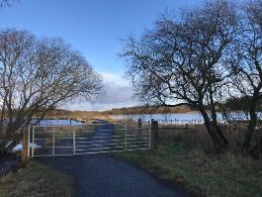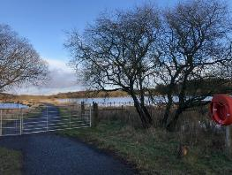
As you reach the East end of the loch, you pass a pilgrims way post and you veer right here, to go past the large house and stable. Just past the house, you turn left, again following the pilgrims way signs. Go through a gate on the left and head North up the old road.
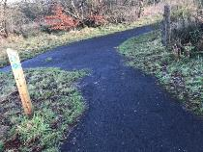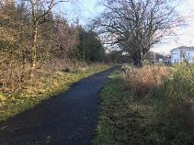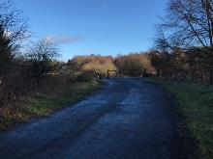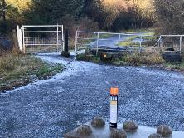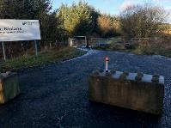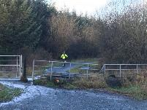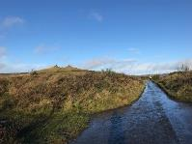
Head north until you approach the walnut whip on your left. The road changes from tarmac to hard core underfoot in this section.
Turn left to skirt the bottom of the walnut whip and at the very large rock, turn right to go up a straight track to meet the paths that encircle the hill/bing. Once you reach the circular paths, you run anti-clockwise up two full circles before reaching the concrete pipe/avenue of mining equipment at the top.
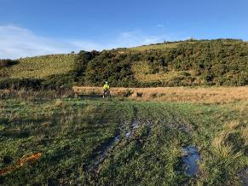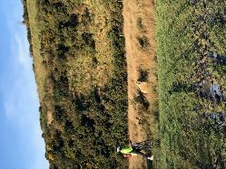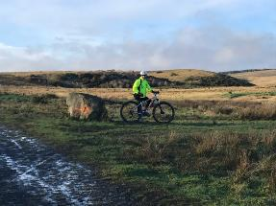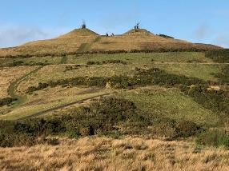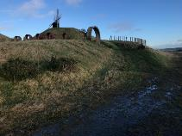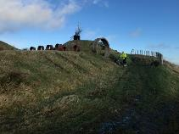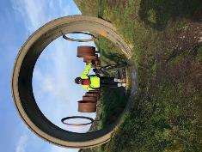
Go through the concrete pipe/avenue of mining equipment and turn left at the end of the equipment (heading west) to go up and over the saddle between the two decorated summits on your left. Descend down the steep slope to the track and turn right. Run in a clockwise direction for 2.25 circles around the hill before veering left (north) at the bottom to a flat path along the lochan. Turn left and run around the bottom of the hill/bing until the track turns right and head in a westerly direction, heading off between two other hills/bings.
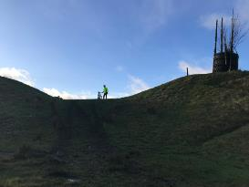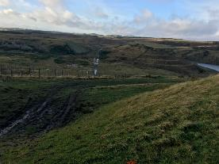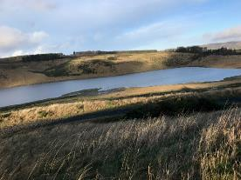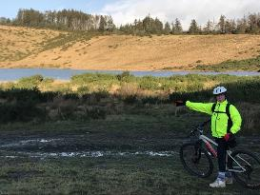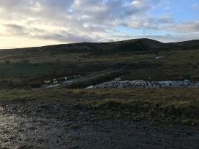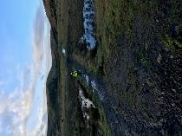
A view looking back to the walnut whip.
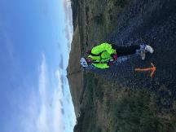
Continue west on the wet and muddy track which eventually opens up to a concrete laydown area. Veer to the left as you leave the laydown area, this time heading south back towards Loch Fitty. After around 300m, turn left again towards woodland and Loch Fitty
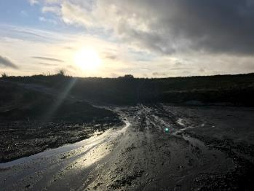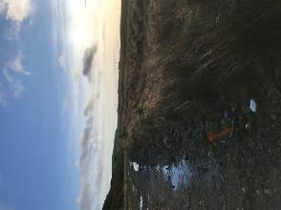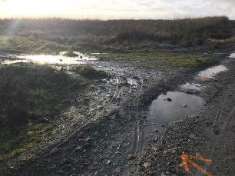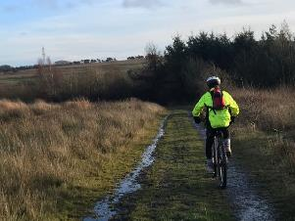
Skirt the edge of the woodland as the track leads you down to a gate immediately followed by a bridge. Cross the bridge and after about 30m turn right at the pilgrims way post. This is you back on the boardwalk through Loch Fitty. The race finishes at the same gate that you started at.
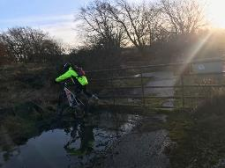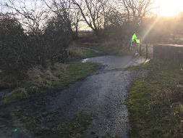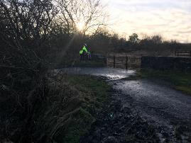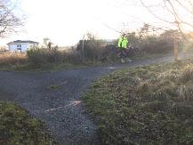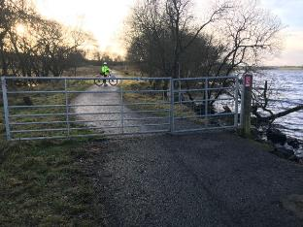

Arial photos of the route, garmin map and plotaroute link are attached.
https://www.plotaroute.com/route/1379708

