Location
Race will take place at Balgownie Woods https://fifewalking.com/fife-walks/fife-balgownie-woods-walk/
Balgownie Wood is in West Fife, halfway between Dunfermline and Kincardine. From the A907, turn south at the '3 mile' sign for Culross. From the A985, turn north at the sign for Balgownie. Balgownie Wood is a two minute drive from each of these junctions on the east side of the road
Sat Nav KY12 8EL is the nearest postcode
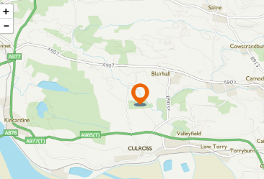

Parking and Walk/Jog to Start
There is parking at the start for a few cars. Can these spaces be left for the race organizers?
Parking is available at Shiresmill Riding Centre KY12 8ER. There is also parking at the opposite end to the race start at Balgownie Woods and near the race start.
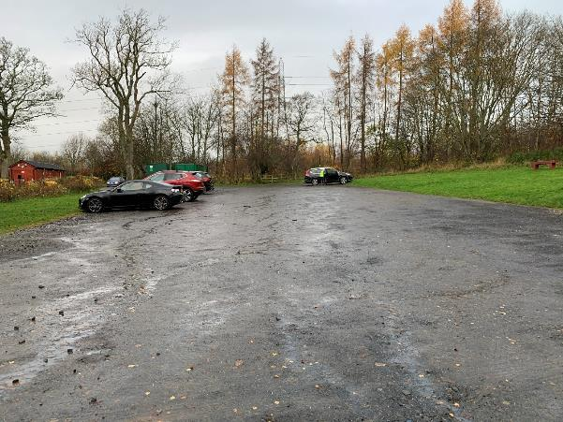
From Shiresmill there is a walk of 0.7miles to the start on the B9037 road, see map and instructions below
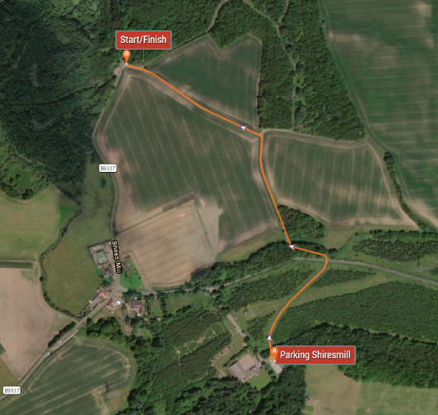
From Shiresmill car park, pass through the wooden fence at the north of the car park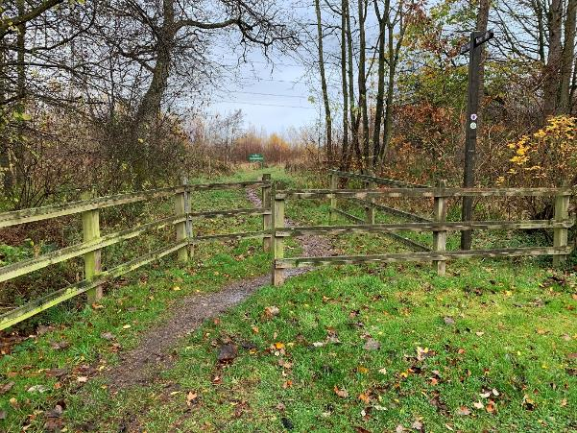
Continue on the path until you reach a gate. Open the gate, cross the road and enter via the gate opposite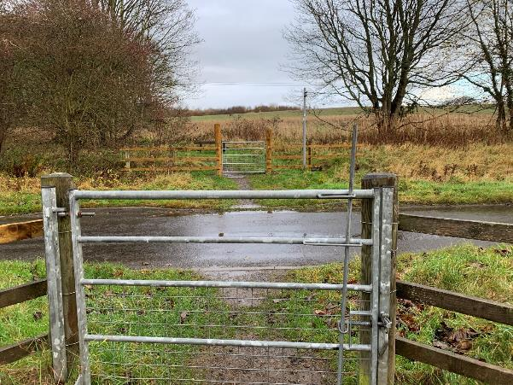
Follow the path around and up a small muddy track
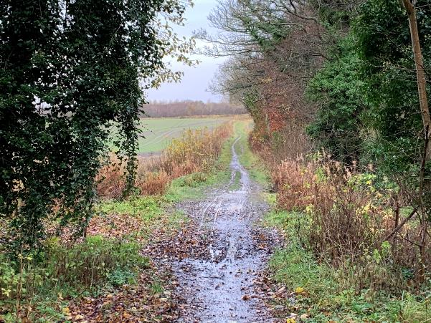
At the top turn left onto a black gravel track across a farmer’s field 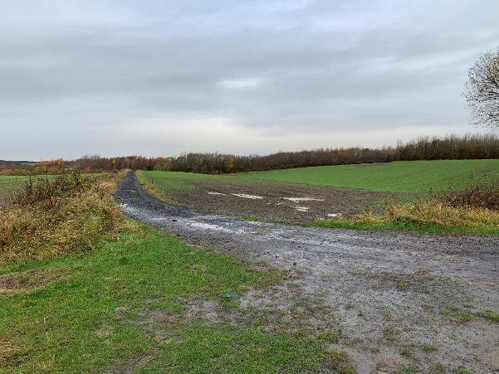
You will pop out here (where the black van is). There is also parking here for a few cars. (Race volunteers only please) 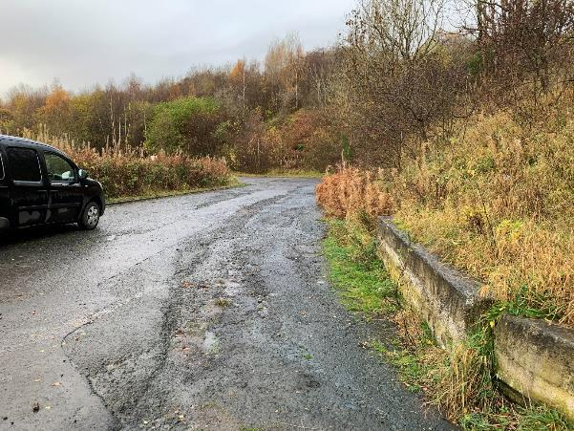
Walk down the hill cross the road and you are at the race start 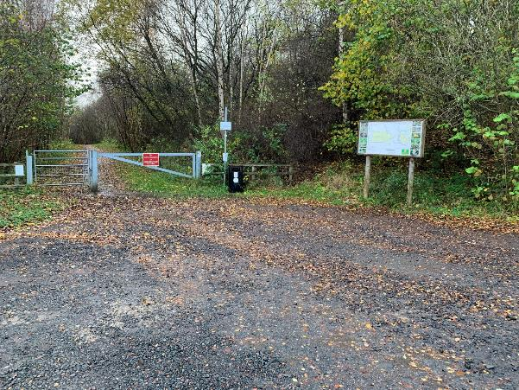

Race Route
There is an animated route here https://www.plotaroute.com/route/1340072?units=miles
Race maps below
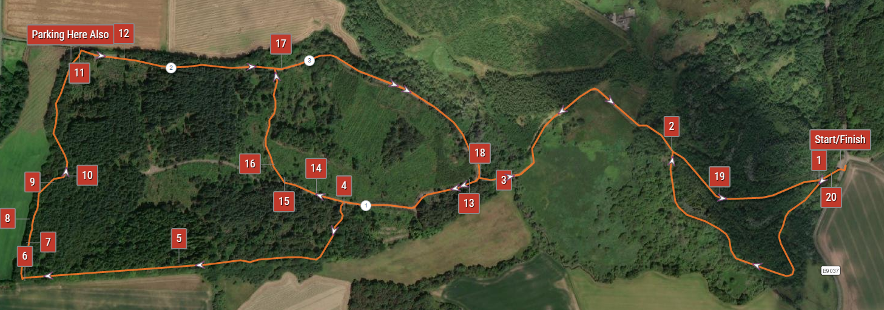

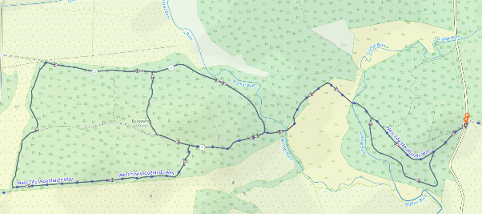
The start is from the small parking area at the side of the B9037 about 1/2 km (1/3 of a mile) north of the village of Shiresmill, near Valleyfield. The spot is easily identifiable by the large board in the car park.
The race will start from the car park after the gate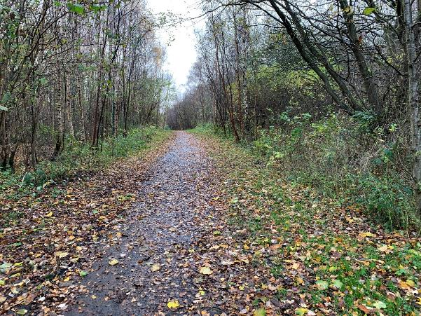

The path takes you into a wooded area. Very soon you will reach a signpost for “Balgownie”. Keep left here to follow the slightly longer loop. The route doubles back on itself but there is only one way to go and the path is well marked.
IMAGE 1 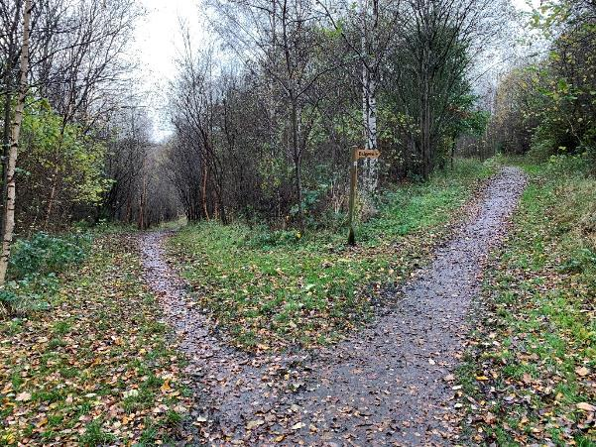
You will soon reach a bench IMAGE 2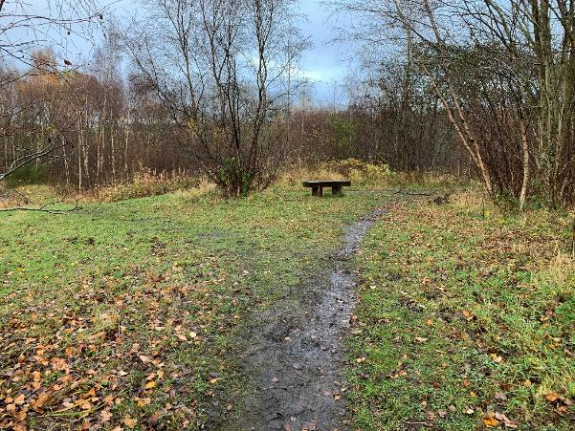
Go left here
You will soon see a picnic bench beside the Grange Burn.
After the picnic bench you cross the burn on a new bridge and run on a good path across a wetland (red shingle path).
Beyond the wetland another bridge takes you across the Bluther Burn and into the Forestry Commission managed Balgownie Wood.
Turn left here on to the forest track IMAGE 3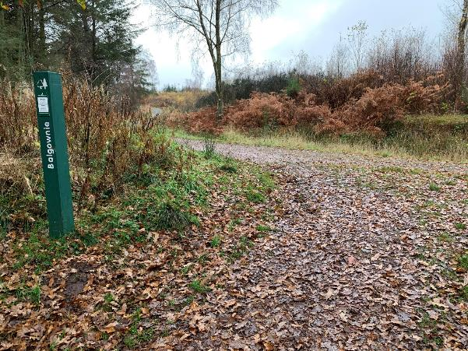
Climb up the hill until you see a small path heading off into the woods on your left hand side (there is a signpost with a West Fife Woodlands Way badge on it). IMAGE 4 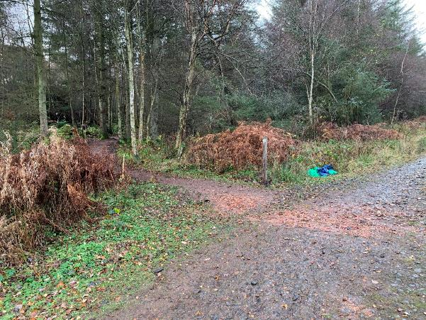
Follow this path firstly through birch trees, then oak and later an “avenue” of beech and what looks like garden conifers.

IMAGE 5
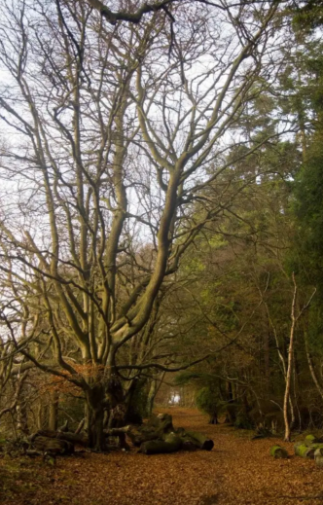
Continue on this path which takes you along the southern edge of the wood close to the boundary fence before turning right to follow the western edge fence.
At the bench at the end of the ‘avenue’ turn right. IMAGE 6 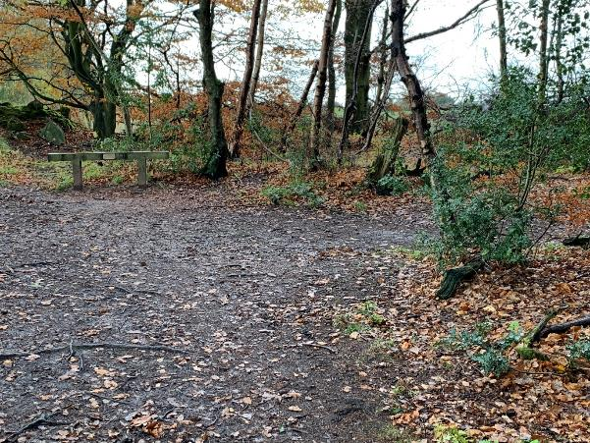
The forest becomes more traditional forestry commission spruce trees for a while as you run on a carpet of shed needles. The path starts to head into the woods away from the boundary fence.

IMAGES 7, 8 and 9
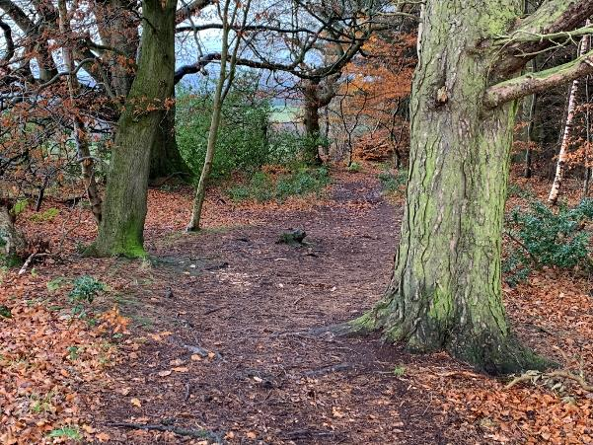
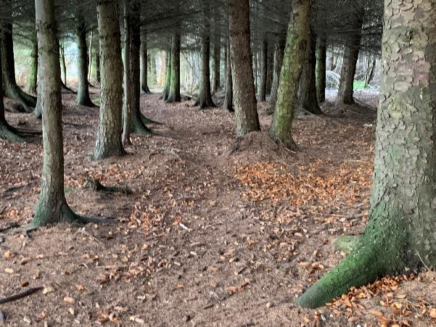
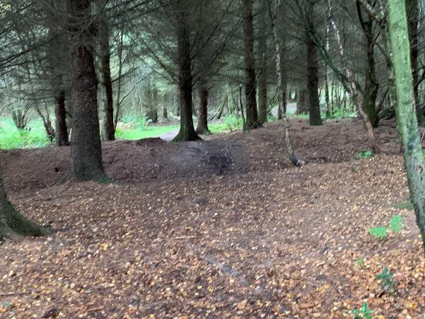
Look out for a path off to your left that will take you back towards the western edge of the forest and into deciduous trees. IMAGE 10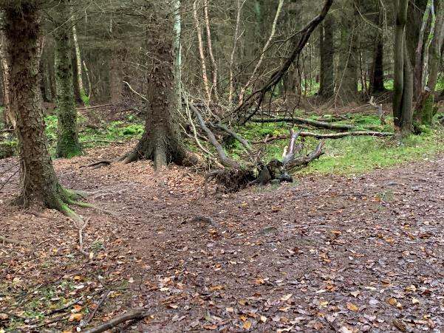
You will soon reach the main forest track at the west entrance to the Balgownie woods. IMAGE 11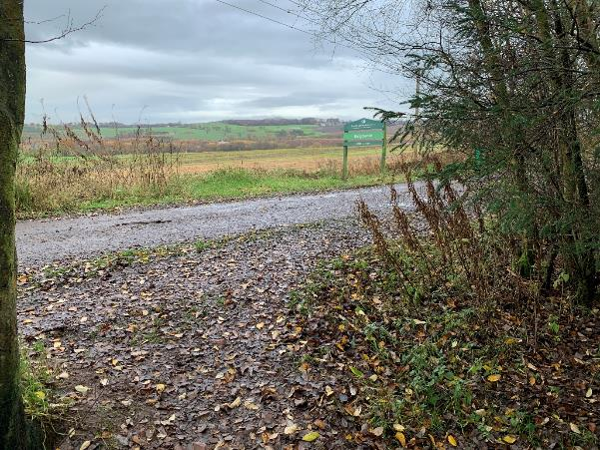
Turn right here and through the green gates at the west entrance to Balgownie Woods IMAGE 12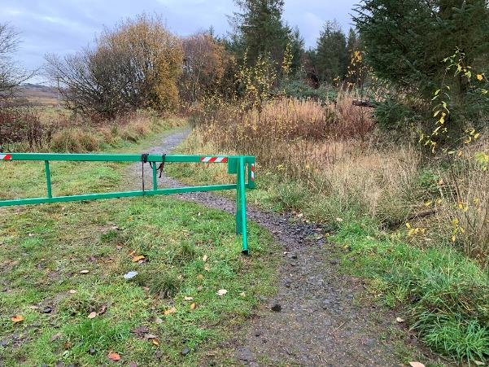
Continue on the well marked grey gravel path back to the where the path after the bridge forks IMAGE 13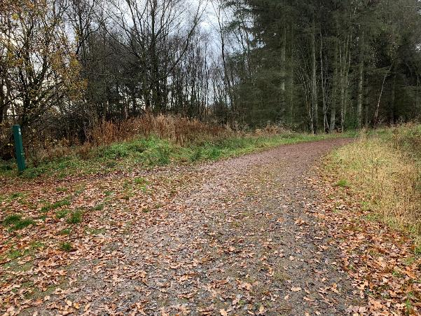
DO NOT GO LEFT Keep right here, past the left hand turn where you headed up hill into the woods before and passed the left hand turn that you took into the “avenue” woods before

IMAGE 14
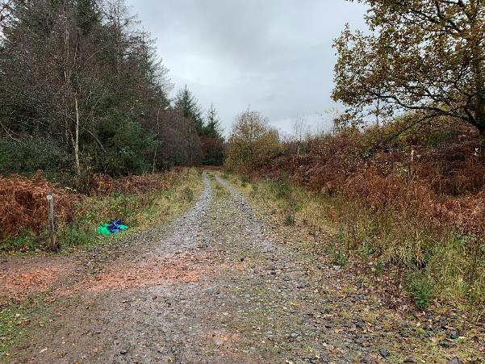
Keep going straight for about X metres then turn right down a narrow muddy steep path IMAGE 15 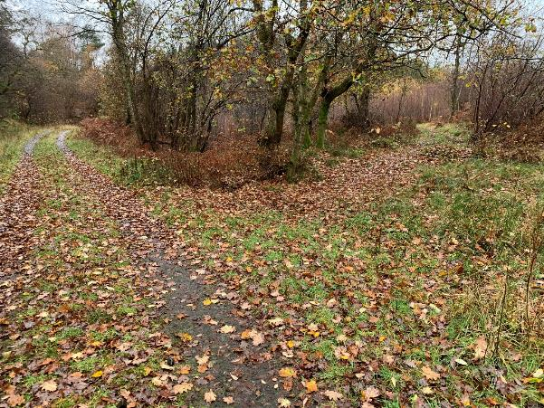

IMAGE 16
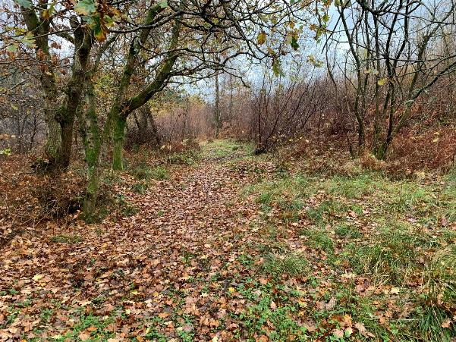
Until you reach the main forest track again. Turn right here and head back IMAGE 17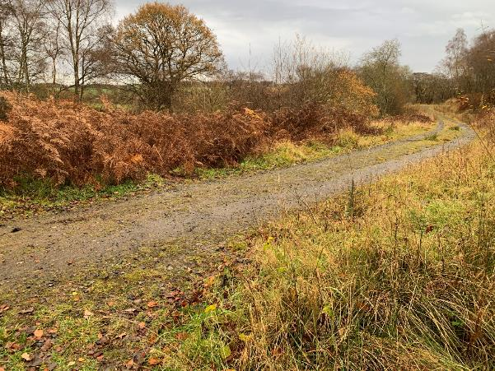
When you get to the fork in the road again DO NOT go up the hill into the woods but turn left back to the race start via the bridge across the Bluther burn IMAGE 18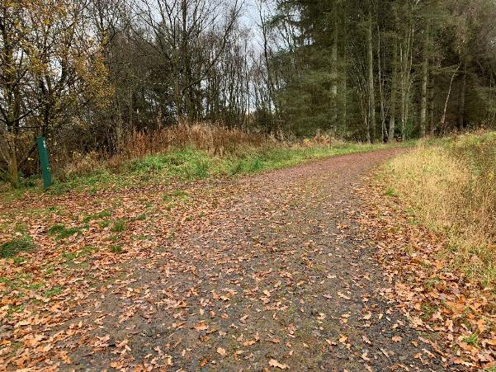

Run through the shingle wetlands path, across the bridge, past the picnic bench and follow the path straight back to the gate at the start. IMAGE 19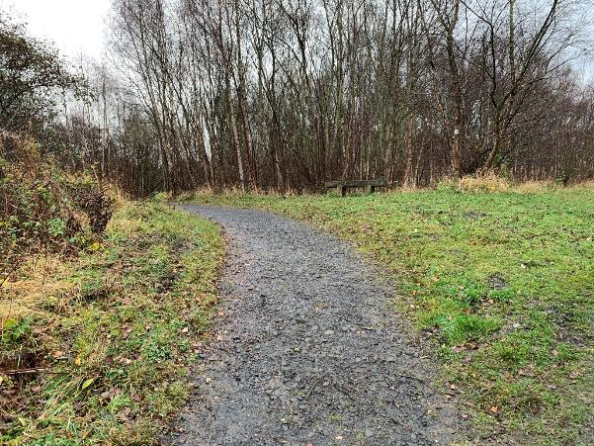

IMAGE 20
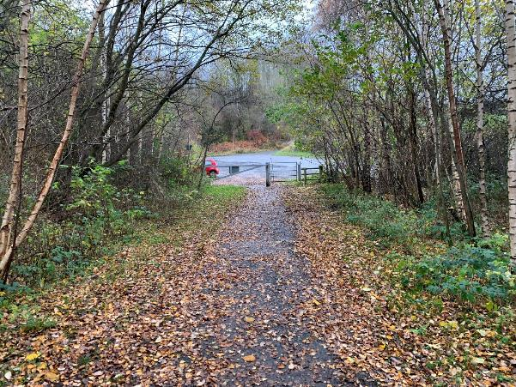
The race will finish at the gate.
Distance is approximately 4 miles

Parking
We would recommend parking at Shiresmill, however, parking is also available for a limited number of cars for race volunteers across from the race start
And at the West entrance to Balgownie woods