Carnegie Harriers Virtual Grand Prix 2020
Festive Forest Route

The route starts and finishes at the gate in the Clentry car park in Blair Adam Forest.
Each year, the route varies dependant on forestry work and this summer’s route is slightly different to the one we ran in December 2019. It is still 7 miles, on trails and hills.
Race start
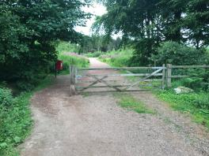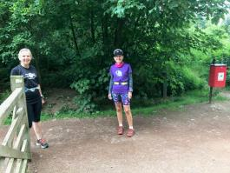
Start at the gate and head along the orange blaes track, past the totem pole and carved brick wall, to the first junction. There you turn left (uphill) onto a grey hard-core track. This track looks quite narrow at first with all the growth on the verges.
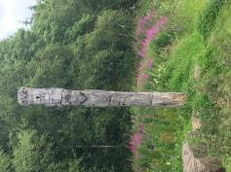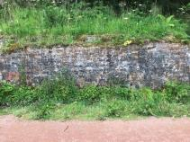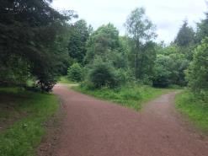

Turn left and head up the track which starts out quite narrow but gets broader after the green gate. There are several turnings to both left and right but continue until you reach the very well sign posted turn for Blairenbaithie Mine Trail. This is 0.9mile into your race.
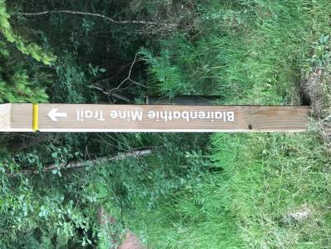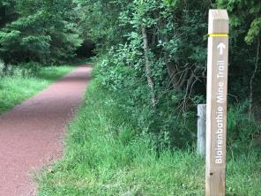
Run along this flat, orange blaes track for about 150m before taking the turning on the right which descends down into the glen to reach Kelty burn.
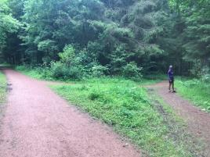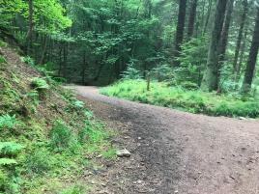
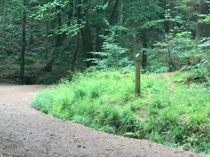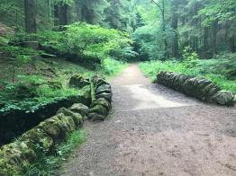
Follow the burn for a few hundred metres before turning left at the junction and starting to climb up the track. You go past a waterfall and the remains of an old bridge and sculpture on the flat track by the burn. Worth admiring on a recce as you’ll be too pre-occupied during your race.
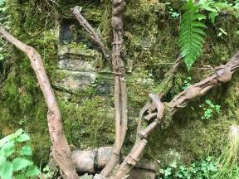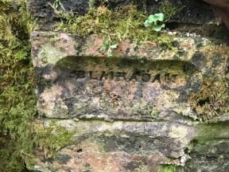
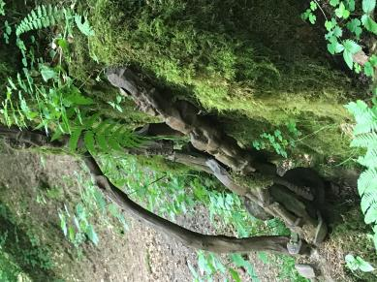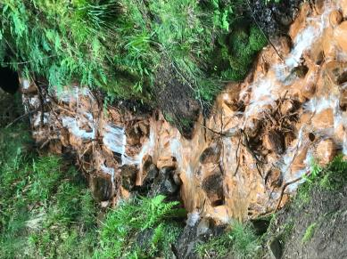
Reach the junction and turn left to begin the climb (track changes again from orange to grey. You pass a turning on the left marked by a yellow ringed way marker, but keep to the right and continue uphill. When you reach a 4 way junction of tracks, turn right and continue uphill.
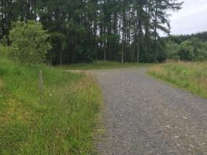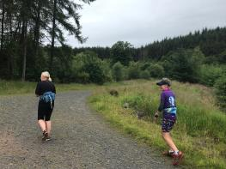
When you’re nearing the high point, there is a choice of track. The main track goes to the right, but you need to go straight on – uphill again! Choose the narrower track Val is on, and not the one on the right where Fiona is. (see photo below left) At the true top of the hill, you can see a mobile phone mast straight ahead. Turn right here onto a level track.
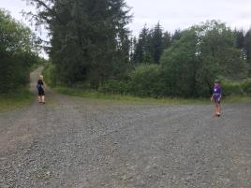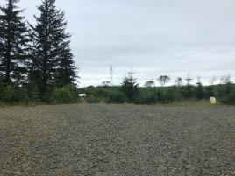
The track is very open here and you can see over to Benarty hill and Loch Leven.
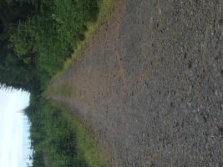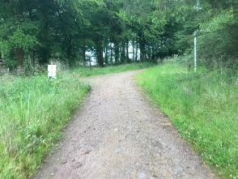
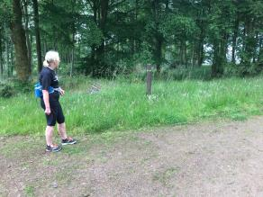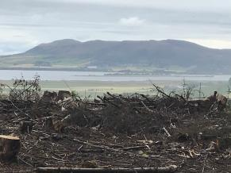
The track descends to a clearly marked junction where you follow the signs to nowhere! All three other roads are named, but you want the un-named but very well made hard core forestry road on the right.
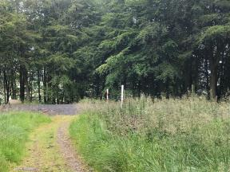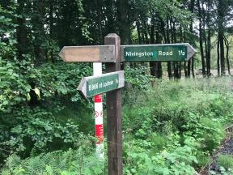
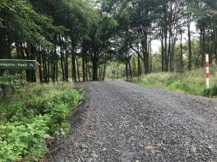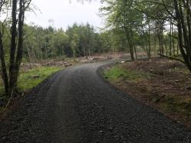
At 4.5miles into the route, you reach the ‘roundabout’. In previous years, we have veered left here but there are so many trees down on this section that the route is impassable. Instead, veer right at the roundabout, and climb half a mile back up to reach one of the main tracks through the forest. When you reach this junction turn left and go downhill.
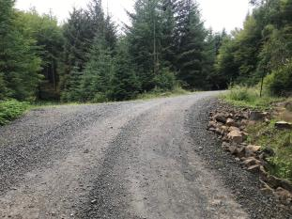 Veer right here, at the ‘roundabout’.

You are now retracing your steps and on your way back. Run down the main track, going straight across at the four way junction. Continue descending until you reach a T junction where you turn right. Follow the track over a green railed bridge and turn left. Follow this track until you reach a junction with the Blairenbathie Mine Trail post.
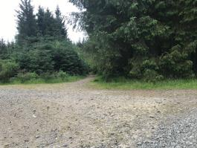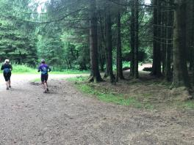
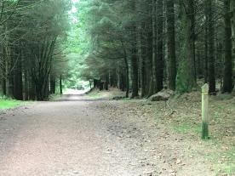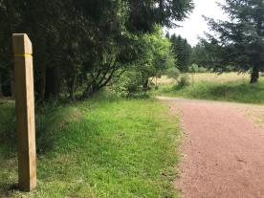

Run down the gently descending track until you reach a junction with a green signpost for the Butterchurn. Turn right here for sting in the tail of the final few hundred metres, uphill to the finish at the gate of the Clentry car park.

Garmin maps are attached below.
