Carnegie Harriers Virtual Grand Prix 2020
Dunfermline Half Marathon Route Description

Dunfermline half marathon has used a variety of routes over the years but has traditionally started and finished in the Glen. In the 1980s and 1990s, the route took runners on one big loop down to Rosyth, Inverkeithing, up the Dales, through RAF Pitreavie Castle and back to the Glen. The final route, about 10 years ago took runners out towards Cairneyhill on the cycle path. Our 2020 route is a two lap route through Duloch which was the route of choice in 2005-6.
Start the route at the Tower Burn end of the flat central path through the Glen. Head towards the peacock sanctuary, then turn right up past the Glen Pavilion, past the parkrun start and then up to the Andrew Carnegie statue. This marks the start of the 6.1mile lap. Run the laps twice in an anti clockwise direction. After the second lap, head into the Glen past the Andrew Carnegie Statue. Head down to the Peacock café and then turn left towards Pittencrieff House (orange limewash). Just before the path goes into the laird’s garden and the glasshouses, take the path on the right which goes around the outside of the laird’s garden. When you reach the flat central path, turn right and head to the finish at the cross roads (where the flat central path and the path up to the Peacock café/tardis meet).
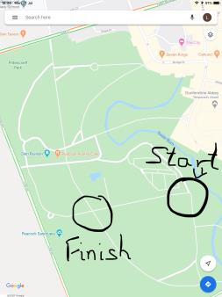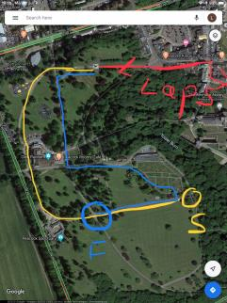
On reaching the Andrew Carnegie statue, head out on the first lap. Head through the Glen gates and up to the city chambers. Turn right into Kirkgate and then left into the Maygate. Continue along Canmore Street until you reach the Alhambra. Turn right onto New Row and then immediately left into Park Avenue. Run along and enter the public park.
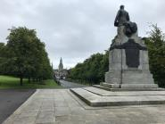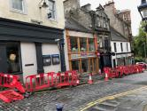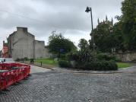
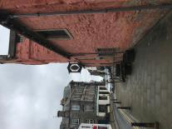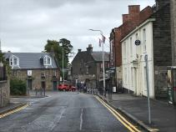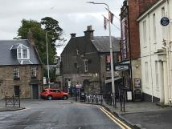
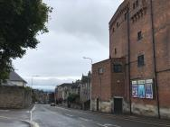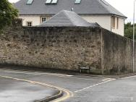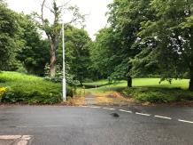
Skirt the playpark, turning left, slightly uphill to reach the underpass below St Margaret’s drive. Head straight on the flat path right through the park, keeping the band stand to the left, and heading towards the Royal Mail sorting office on Woodmill road. Cross over the railway bridge and turn left onto Woodmill Road.
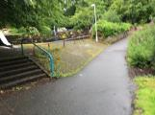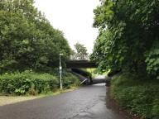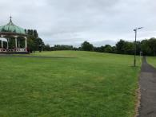
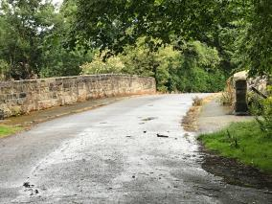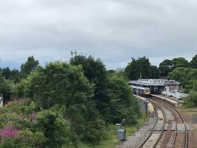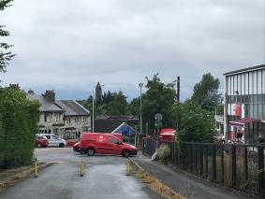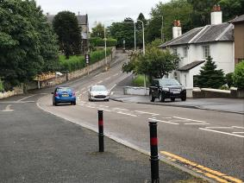
Run along Woodmill road, past the Mosque, Woodmill and St Columba’s high schools and turn right onto Linburn road at Luca’s restaurant. Cross the road here, and turn left onto Trondheim Parkway. Turn left again when you reach Greenshanks Drive and continue until you reach Dunlin Drive. Head down to return to Linburn road where you turn right. Looking across the playing fields, you can see St Columba’s and Woodmill high schools. Run along Linburn Road until you reach the T junction with Halbeath Road where again you turn left.
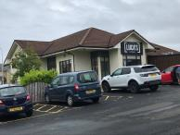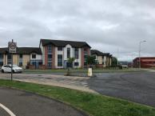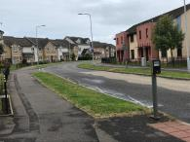
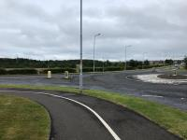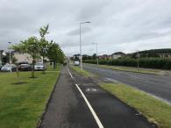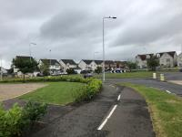

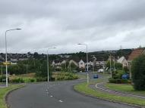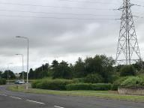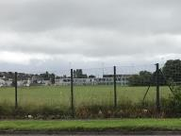
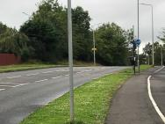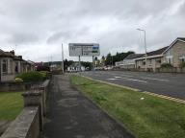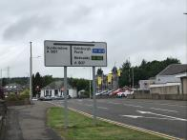
Head back into Dunfermline, through the tunnel under the railway, past the Elizabethan pub, East End Park and just before you reach the Sinclair Gardens roundabout, turn left at the shop into Couston Street, right onto Transy Place and finally left into Park Place to enter the Public Park at the gap in the wall.
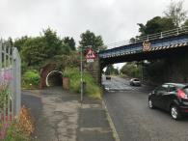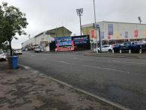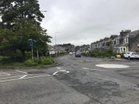
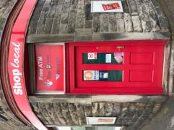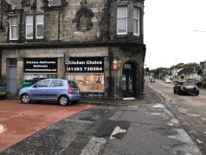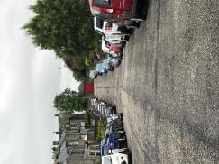
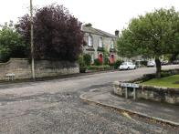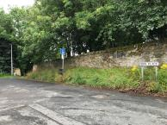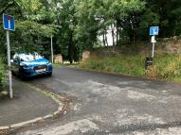
Once inside the public park, follow the paths cutting diagonally across it, past the new playpark area, towards the band stand and St Margaret’s drive underpass. Then turn left and run around the play park area to reach Park Avenue. From there, head along to the Alhambra.
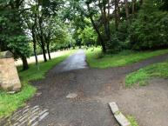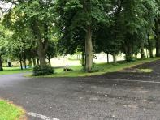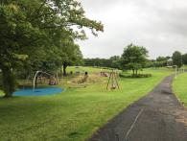
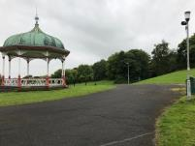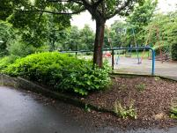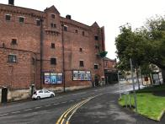
From the Alhambra, head back along Canmore Street, the Maygate and Kirkgate heading for the Glen gates. Once inside the Glen, run around the Andrew Carnegie statue and head back out on a second lap. Each lap is around 6.1miles long.
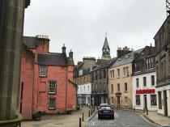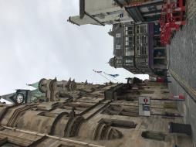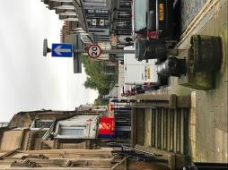
The half marathon consists of the start on the flat, round and up to the Andrew Carnegie statue, two laps around Duloch, and then a return past the statue , past Peacock café, Pittencrieff house and a finish at the cross roads on the flat.

