**Pattiesmuir 5 route description**

Well worth a recce before racing.

Start at primrose lane Rosyth, accessing at the grange road, primrose lane junction.  Parking available on street on primrose lane, Stephens the bakers or other light industry car parks, or at Rosyth halt car park, almost a mile east at the other end of primrose lane.

**Start**.

 Start at the gate by the yellow primrose cottage sign (the gate is permanently open), about 10m in from the road junction and head west. About 125m in, go to the left of the metal gate and keep heading west.

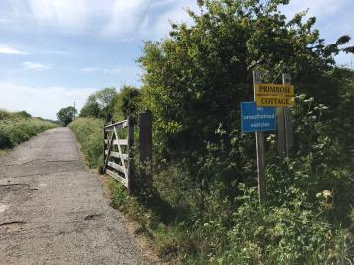  
Start at the wooden gate.

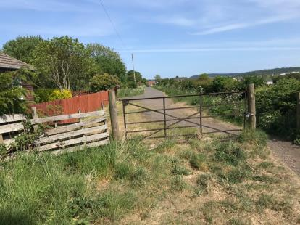

This photo looks back to the start and is about 125m into the route.

Head west, towards the houses of Pattiesmuir, ignoring paths coming in from the right and left.  Follow the track round the bend to the left, past the old pig farm and onto the tarmac road (turn right onto the road) and continue west through the houses.  At the T junction at the end, take a right towards the cemetery.  Just before the cemetery, turn left, up the track that runs around the edge of the cemetery.  Continue on this path until you reach the metal gate into the woods.  This is 1.4 miles from the start.

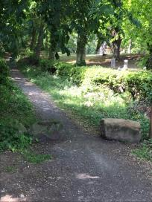

Path heading uphill around the cemetery

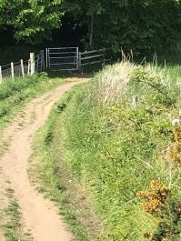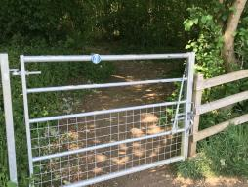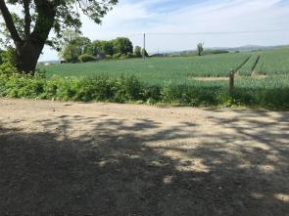

Pedestrian access gate, take the left track and then left at the T junction at the end.

Once through the gate, follow the path veering left through the wood.  Take a left at the T junction by the Pilgrims Way sign junction and then a right onto the Limekilns road, heading back to Dunfermline.  There is a narrow blaes pavement here.  Take the next farm track on the right, again marked by another Pilgrims Way post.  Up a gentle rise, then take a right at the Orange coloured, Wester Gellet farm house.  This starts the loop which is 1.2 miles long and runs clockwise and takes you back again to Wester Gellet farm house. (This is shown as Chicos party on Google maps).

The loop goes from Wester Gellet farm house along a good farm track until you reach the Limekilns road. You turn right at the road junction and using the narrow blaes pavement head towards Dunfermline. Turn right onto the farm track taking you back to Wester Gellet farm house. The loop length is 1.2 miles.

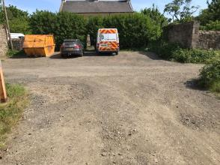

Wester Gellet farm house. Turn right here to begin the loop, and left to head to the finish after the first loop.

After running the 1.2 mile loop, turn left at Wester Gellet.  Take the track on the right just after the Orange cottages and head to Blackhall farm house.

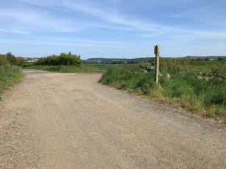

Turn right here to head to Blackhall farm

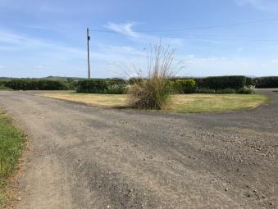

.

On reaching Blackhall farm, take the first track on the right which takes you around the barn. The track on the right is just before this patch of pampas grass. The track goes past some cottages and a barn and sweeps left past a couple of grain silos. Just past the weigh bridge, pick up the main track again on the right, by the tree and outbuilding. (This avoids you running right outside the kitchen window of Blackhall farm and is preferred for privacy reasons.

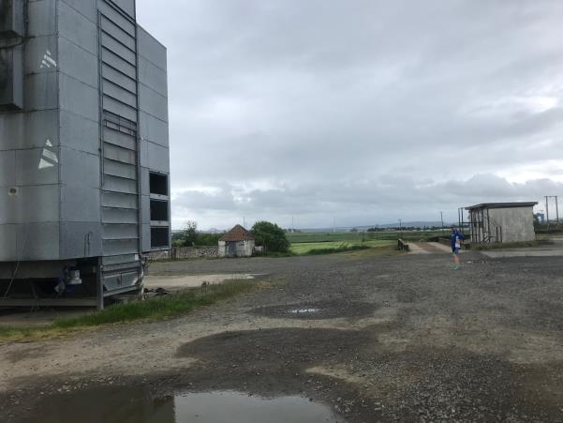

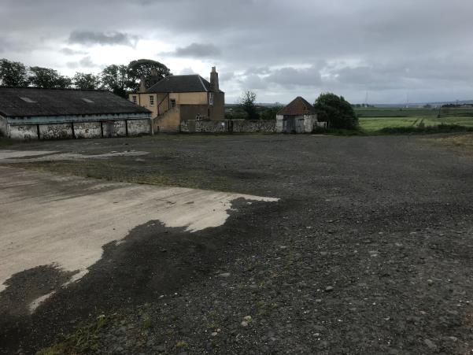

The track continues to the right of the tree and pan tiled outbuilding.

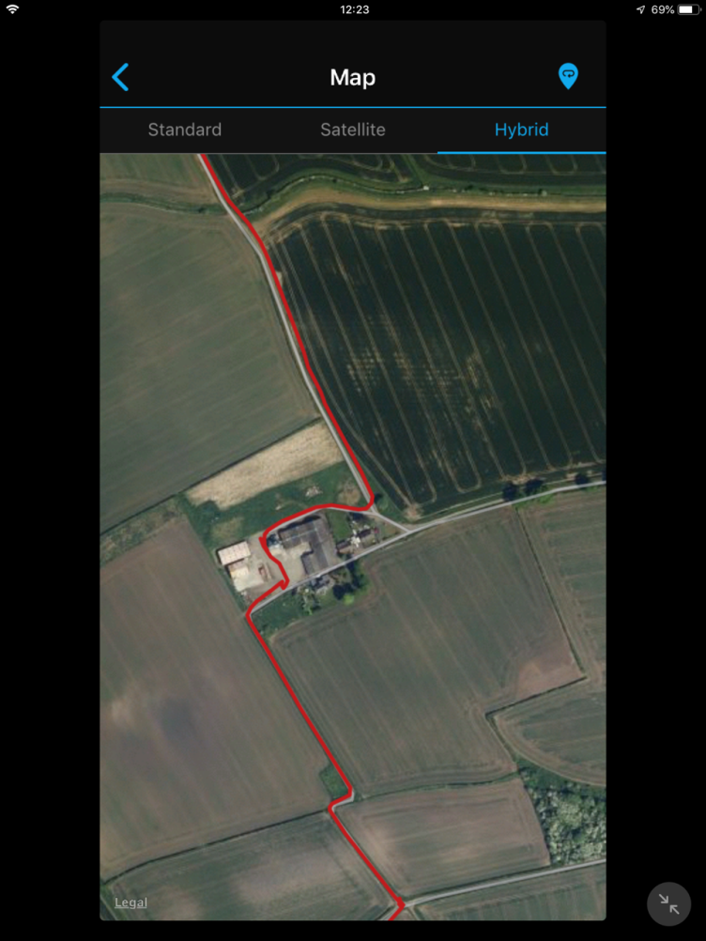

This close up of the route map shows the route through Blackhall farm.

Follow the farm track around between hedges edging fields.  The track twists a bit but there are no alternative routes until you come to a junction of tracks.  You turn left here to return to the finish at the wooden gate by the primrose cottage sign.

Total distance between 4.95 and 4.99 miles.

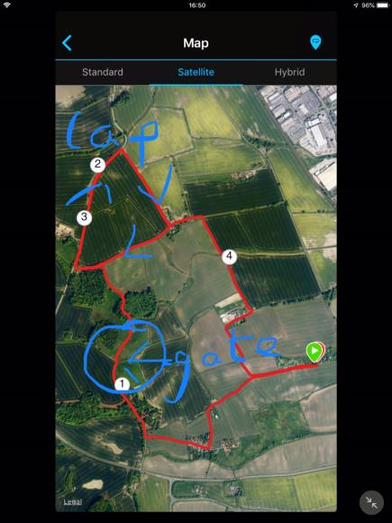

See the close up photo for the preferred route past Blackhall farm.

Srtart and finish at the wooden gate with the Primrose Cottage sign, at the junction of Grange road, Brankholm Brae and Primrose Lane Rosyth.