Carnegie Harriers virtual Challenge 2020
Auld Toun 10k.

The route starts and finishes in the Glen (Pittencrieff Park) outside the Peacock café. There are 3 laps of the city centre running in a clockwise direction – up Carnegie Drive to the police station/Carnegie hall roundabout and then back down to the Glen via the high street. Old timers who remember this route from 10+ years ago will remember that the route then ran in an anticlockwise direction. However on race day, Carnegie drive was coned off so that runners could run down without worrying about traffic. We don’t have that luxury so must run clockwise so we can see oncoming traffic.

Start and lap 1
Start outside the Peacock café at the Glen pavilion. Start and finish is at exactly the same spot.
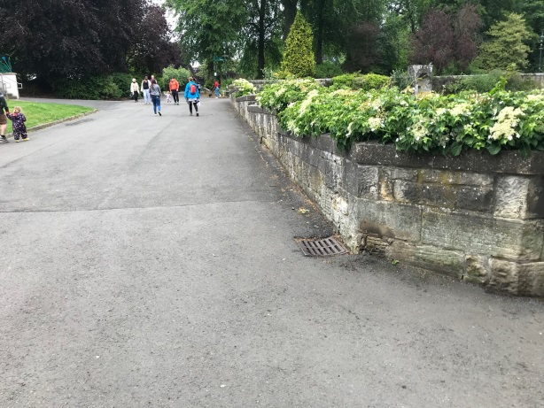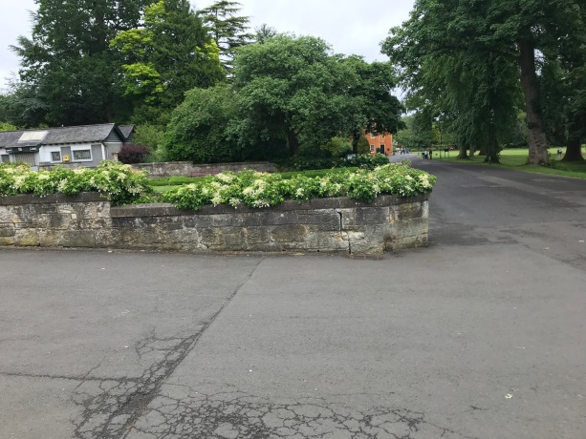
Head north along the path with the children’s play areas to your left and leave the glen at the gates (opposite the Glen tavern), turning right onto Carnegie drive. Run on the pavements, taking care at all road crossings and head gently uphill, past tesco fire station, and the Kingsgate shopping centre. Turn right at the roundabout going past St Margaret’s RC church to head back along the east port.
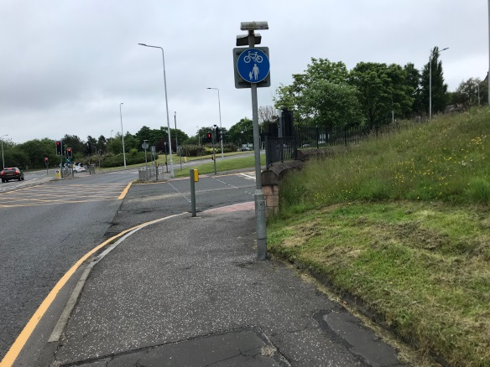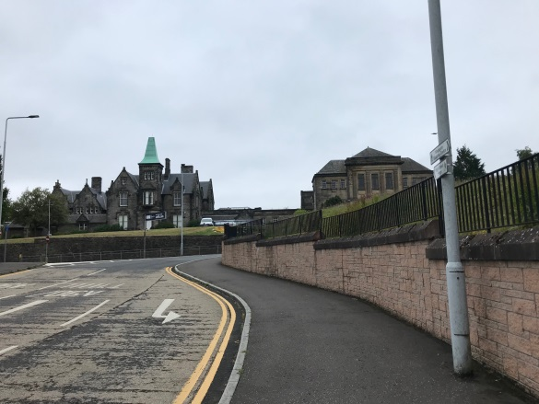

Run down the High Street and enter the Glen again at the Louise Carnegie gates. Take the path which veers slightly down to the left. This takes you down behind the train.
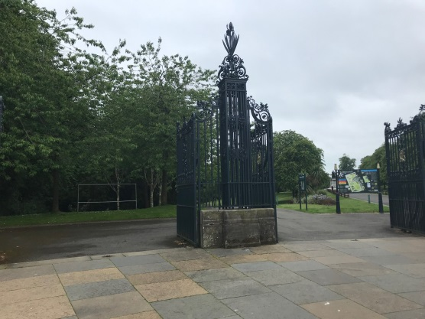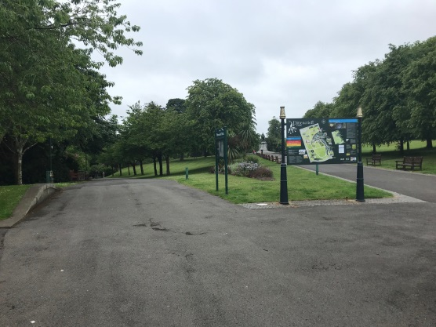
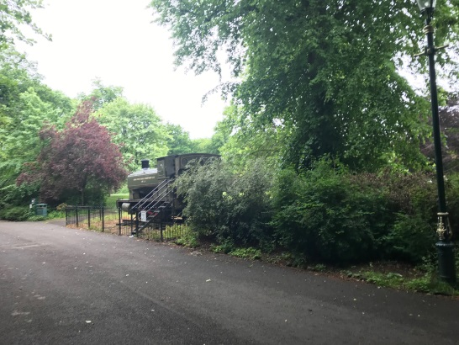

Jink right to come onto the path at the Peacock café before turning left to head towards Pittencrieff house (orange building).
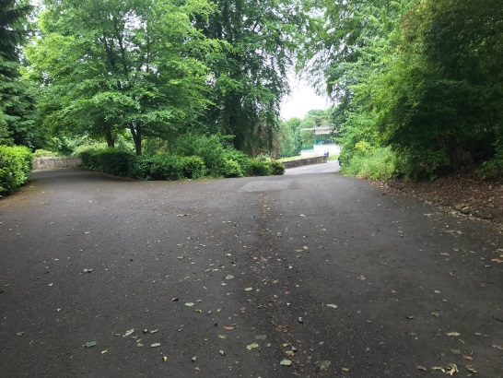
Run in front of the glass houses and follow the path by the hedge down to the archway. Turn right through the archway.
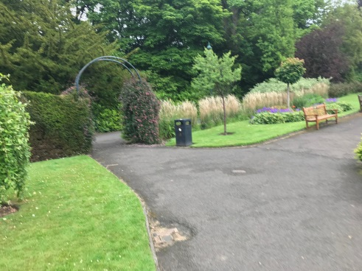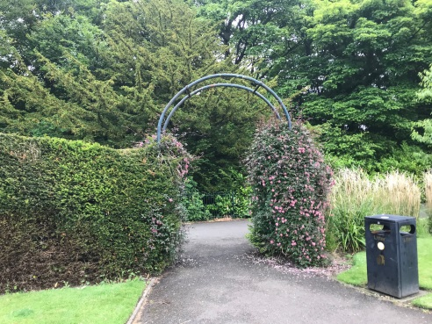
Take the next right and run right along the broad flat central path.
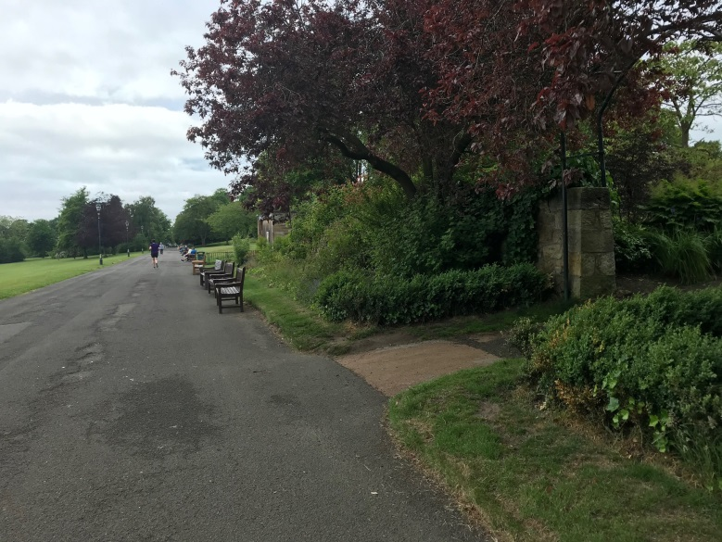
At the end of the path, turn right up past the Glen Pavilion. The path then merges briefly with road access into the car park (so beware of traffic) before picking up the path on the right which is used as the start of the Dunfermline parkrun. Mind the bollards!
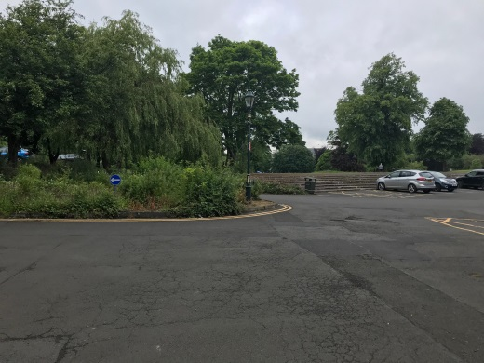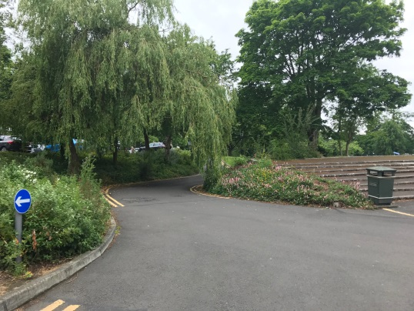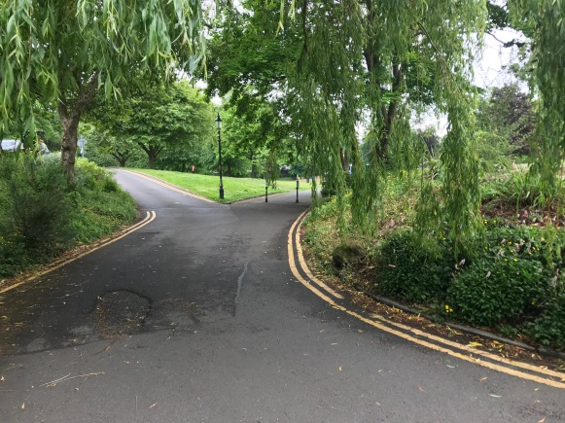
At the end of this path, turn left towards the gates and then right onto Carnegie drive to begin the second lap.
Lap 2
Run a full lap again, up Carnegie drive, down the high street, into the Glen, past the train, past the glasshouses, round past the Glen Pavilion and out again, opposite the glen tavern.
Lap 3.
Leaving the park at the Glen tavern gates, head up Carnegie Drive as before, turning at St Margaret’s RC church and back into the Glen. Run down the path as before past the train, left at the Peacock café, past the glass houses, through the arch and onto the broad, flat central path.
This time, at the big junction of paths, turn right and return to the starting point outside the Peacock café.
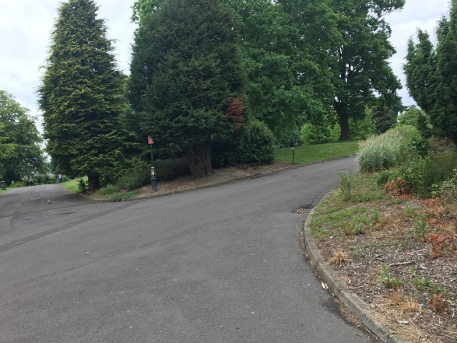

Route map
